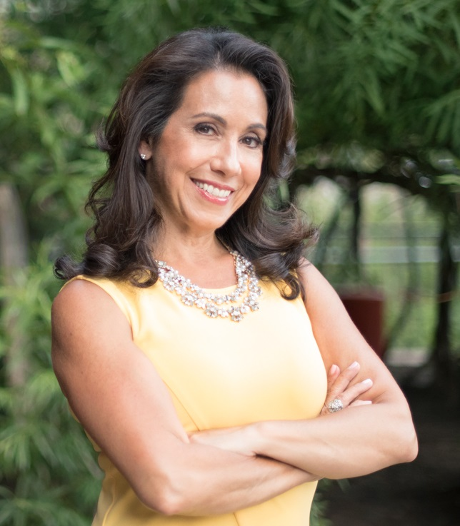
Louisa Jewell, MAPP
Professional Bio

Louisa Jewell is a speaker, author and positive psychology expert who has facilitated thousands of people towards greater flourishing both at work and in their personal lives.
Louisa is the Founder of the Canadian Positive Psychology Association (www.cppa.ca) an organization that brings together leading-edge researchers and practitioners to share the latest knowledge on psychological well-being to improve the mental health of all Canadians.
Louisa is a graduate of the Master of Applied Positive Psychology (MAPP) program at the University of Pennsylvania. Louisa teaches positive psychology at the University of Texas, Dallas, she was an instructor at the University of Toronto and regularly delivers webinars and workshops to educators and practitioners around the world.
Her work has been featured in Forbes, The Globe and Mail, Toronto Star, Huffington Post, Canadian Living Magazine, Live Happy Magazine, Chatelaine, Psychology Today, Women's Agenda, Toronto Sun, to name a few. She is a contributing author to the European Handbook of Positive Psychology, Positive Psychology at Work and Positive Psychology News Daily. Her book Wire your Brain for Confidence; The Science of Conquering Self-Doubt will be released in September, 2017.
For more information visit: www.louisajewell.com

